Streamdeck testing

1. Factory reset (save IP/EDID/ID)
2. PGM+PVW Mode
3. Auto add all inputs and outputs
4. ScreenDest1: 3 SL mix layers
5. ScreenDest2: 2 SL single layers
6. AuxDest1

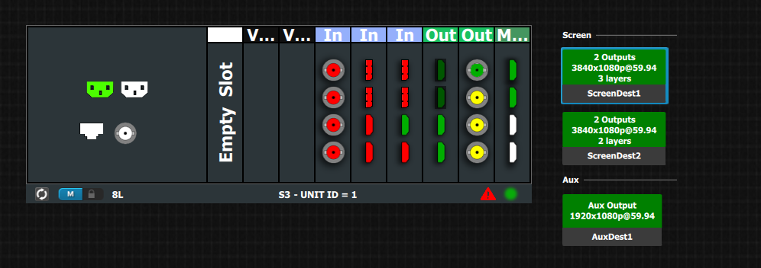

1. **No prior states**

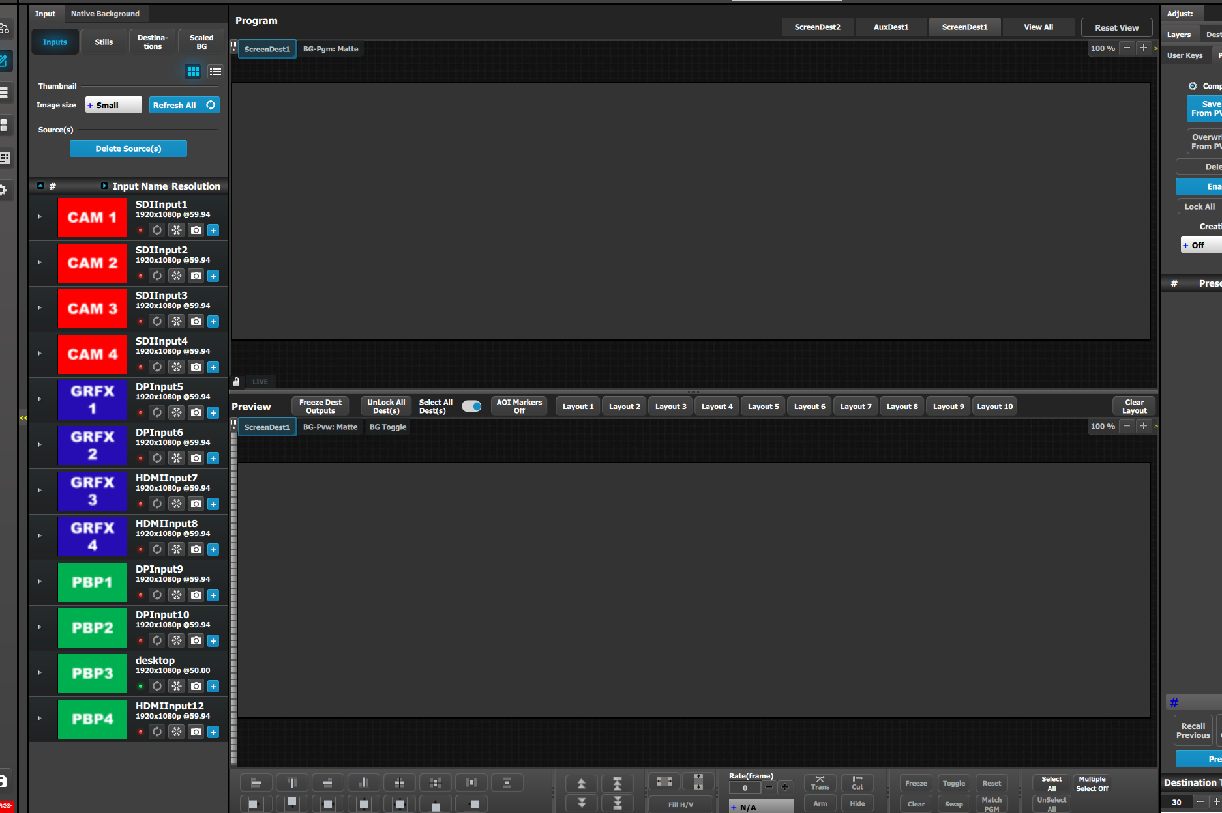

1. **Destination = Dest 1, Layer=mix Layer1, Source=SDIInput1 to PVW**

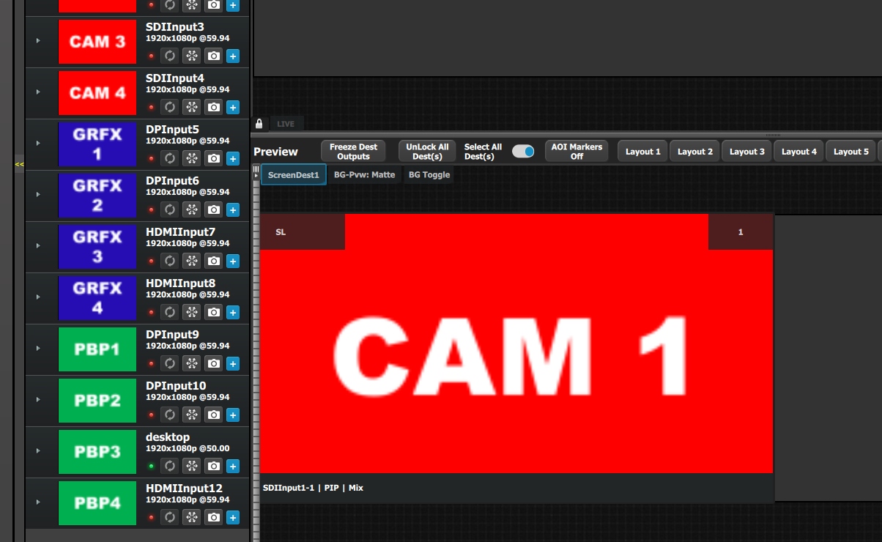

1. **Destination = Dest 1, Layer=mix Layer1, Source=SDIInput1 to PGM**

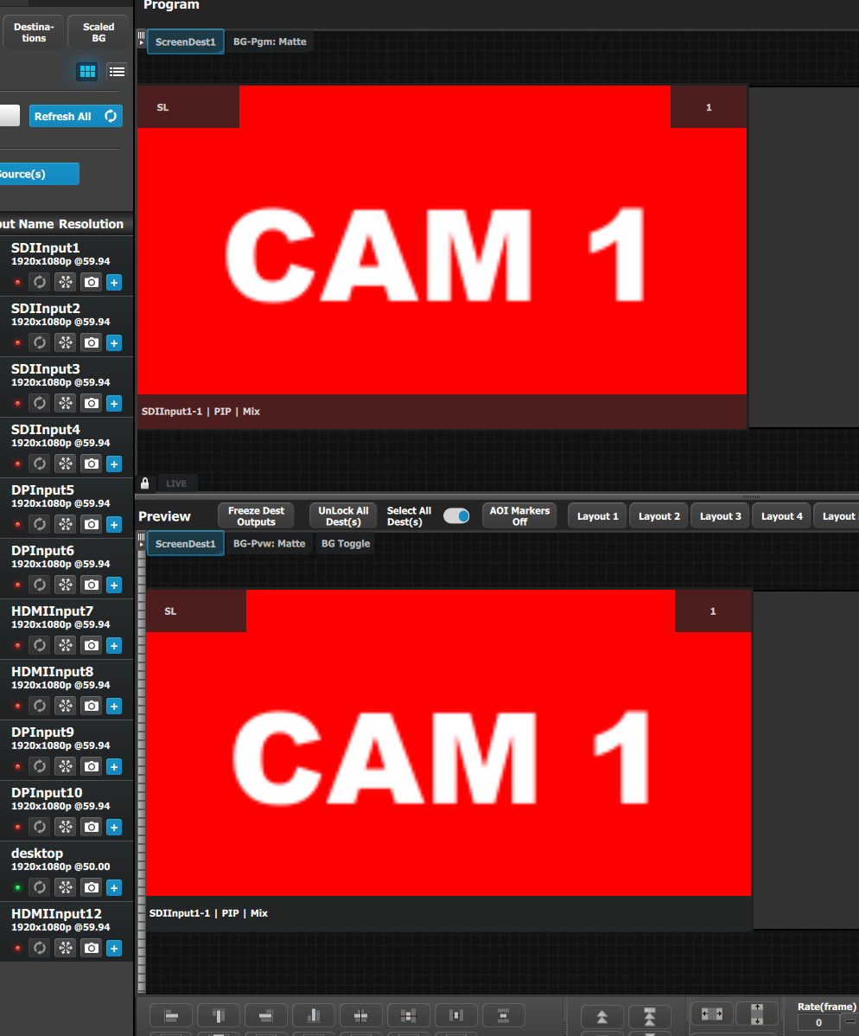

1. **Clear layer from PGM, all trans**

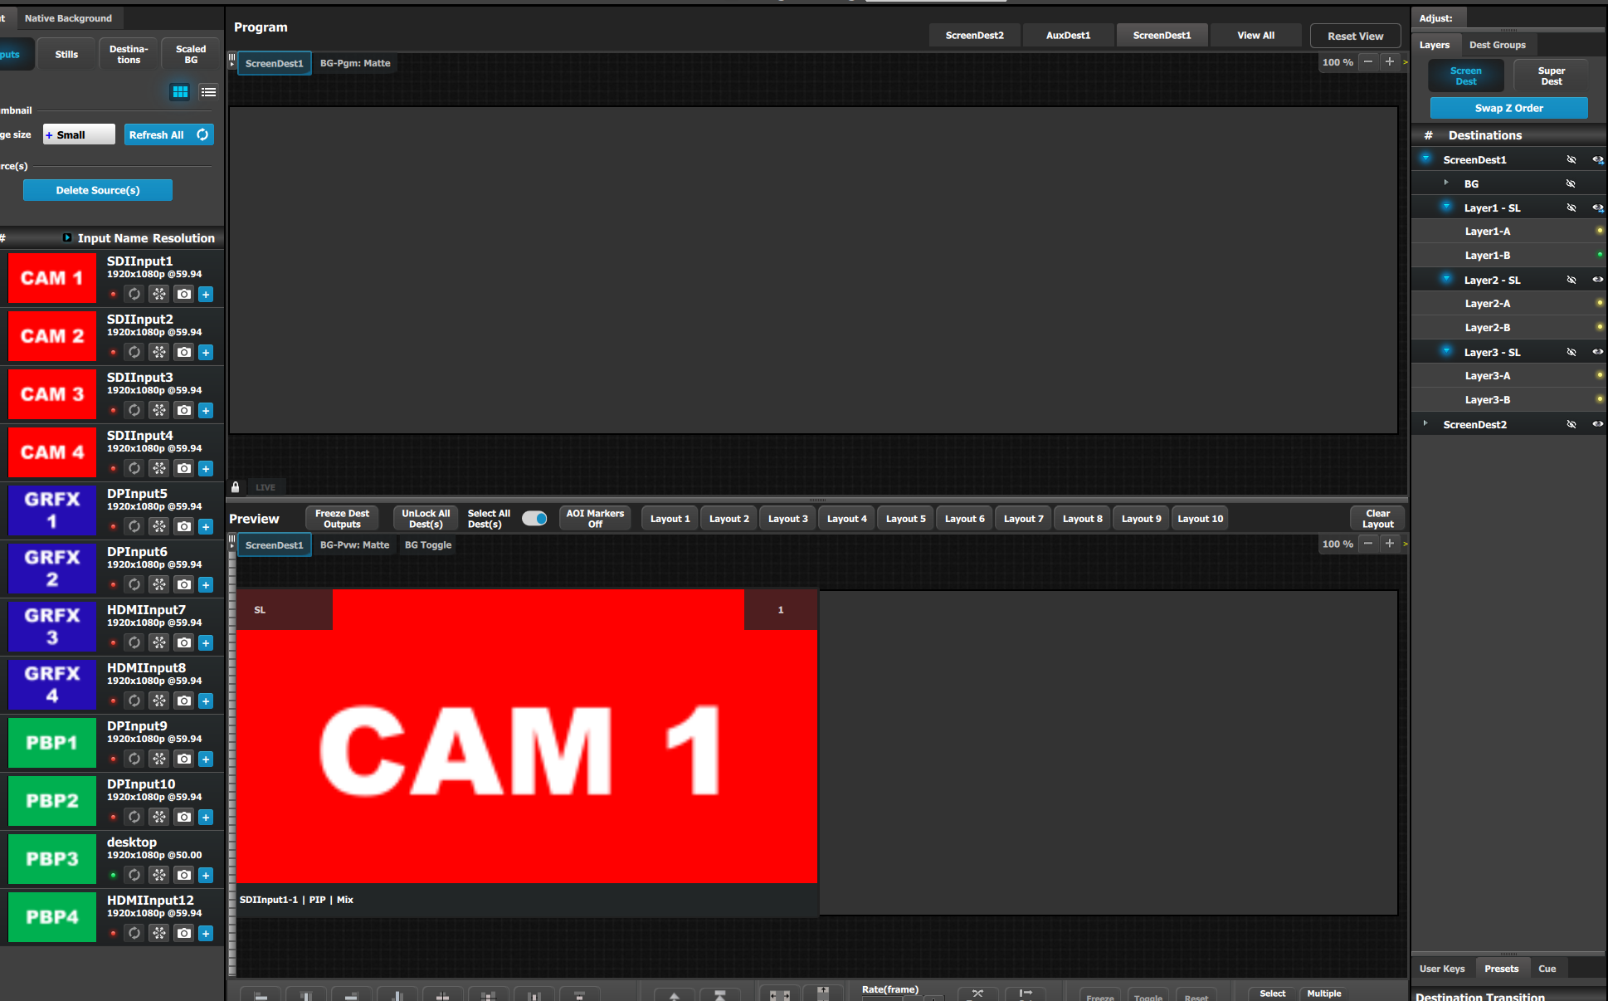

1. Destination = Dest 1, Layer=mix Layer1, Source=SDIInput1 to PGM

*RESULT: Unexpected Results*

1. *Expected ListContent PVMmode to be set to 1 (it is set to 0)*
2. *Calling changeContent with Layer.id =1 (layer-1B) and PgmMode=1 results in no change*

*Questions:*

1. *What is the proper way to I know whether the mix layer is in preview or program?*
2. *Why did it not “ADD” layer-1B to PGM?*

ommand Sents: listContent followed by changeContent

listContent response: {"jsonrpc":"2.0","result":{"success":0,"response":{"id":0,"Name":"ScreenDest1","BGLyr":[{"id":0,"LastBGSourceIndex":-1,"BGShowMatte":1,"BGColor":{"id":0,"Red":0,"Green":0,"Blue":0}},{"id":1,"LastBGSourceIndex":-1,"BGShowMatte":1,"BGColor":{"id":0,"Red":0,"Green":0,"Blue":0}}],"Layers":[{"id":0,"Name":"Layer1-A","LastSrcIdx":-1,"PvwMode":0,"PgmMode":0,"Capacity":1,"PvwZOrder":0,"PgmZOrder":0,"Freeze":0,"Window":[{"HPos":0,"VPos":0,"HSize":1920,"VSize":1080},{"HPos":0,"VPos":0,"HSize":1920,"VSize":1080}],"Source":[{"HPos":0,"VPos":0,"HSize":1920,"VSize":1080},{"HPos":0,"VPos":0,"HSize":1920,"VSize":1080}],"Mask":[{"id":0,"Top":0,"Left":0,"Right":0,"Bottom":0},{"id":0,"Top":0,"Left":0,"Right":0,"Bottom":0}]},{"id":1,"Name":"Layer1-B","LastSrcIdx":-1,"PvwMode":0,"PgmMode":0,"Capacity":1,"PvwZOrder":0,"PgmZOrder":0,"Freeze":0,"Window":[{"HPos":0,"VPos":0,"HSize":1920,"VSize":1080},{"HPos":0,"VPos":0,"HSize":1920,"VSize":1080}],"Source":[{"HPos":0,"VPos":0,"HSize":1920,"VSize":1080},{"HPos":0,"VPos":0,"HSize":1920,"VSize":1080}],"Mask":[{"id":0,"Top":0,"Left":0,"Right":0,"Bottom":0},{"id":0,"Top":0,"Left":0,"Right":0,"Bottom":0}]},{"id":2,"Name":"Layer2-A","LastSrcIdx":-1,"PvwMode":0,"PgmMode":0,"Capacity":1,"PvwZOrder":2,"PgmZOrder":2,"Freeze":0,"Window":[{"HPos":0,"VPos":0,"HSize":1920,"VSize":1080},{"HPos":0,"VPos":0,"HSize":1920,"VSize":1080}],"Source":[{"HPos":0,"VPos":0,"HSize":1920,"VSize":1080},{"HPos":0,"VPos":0,"HSize":1920,"VSize":1080}],"Mask":[{"id":0,"Top":0,"Left":0,"Right":0,"Bottom":0},{"id":0,"Top":0,"Left":0,"Right":0,"Bottom":0}]},{"id":3,"Name":"Layer2-B","LastSrcIdx":-1,"PvwMode":0,"PgmMode":0,"Capacity":1,"PvwZOrder":2,"PgmZOrder":2,"Freeze":0,"Window":[{"HPos":0,"VPos":0,"HSize":1920,"VSize":1080},{"HPos":0,"VPos":0,"HSize":1920,"VSize":1080}],"Source":[{"HPos":0,"VPos":0,"HSize":1920,"VSize":1080},{"HPos":0,"VPos":0,"HSize":1920,"VSize":1080}],"Mask":[{"id":0,"Top":0,"Left":0,"Right":0,"Bottom":0},{"id":0,"Top":0,"Left":0,"Right":0,"Bottom":0}]},{"id":4,"Name":"Layer3-A","LastSrcIdx":-1,"PvwMode":0,"PgmMode":0,"Capacity":1,"PvwZOrder":4,"PgmZOrder":4,"Freeze":0,"Window":[{"HPos":0,"VPos":0,"HSize":1920,"VSize":1080},{"HPos":0,"VPos":0,"HSize":1920,"VSize":1080}],"Source":[{"HPos":0,"VPos":0,"HSize":1920,"VSize":1080},{"HPos":0,"VPos":0,"HSize":1920,"VSize":1080}],"Mask":[{"id":0,"Top":0,"Left":0,"Right":0,"Bottom":0},{"id":0,"Top":0,"Left":0,"Right":0,"Bottom":0}]},{"id":5,"Name":"Layer3-B","LastSrcIdx":-1,"PvwMode":0,"PgmMode":0,"Capacity":1,"PvwZOrder":4,"PgmZOrder":4,"Freeze":0,"Window":[{"HPos":0,"VPos":0,"HSize":1920,"VSize":1080},{"HPos":0,"VPos":0,"HSize":1920,"VSize":1080}],"Source":[{"HPos":0,"VPos":0,"HSize":1920,"VSize":1080},{"HPos":0,"VPos":0,"HSize":1920,"VSize":1080}],"Mask":[{"id":0,"Top":0,"Left":0,"Right":0,"Bottom":0},{"id":0,"Top":0,"Left":0,"Right":0,"Bottom":0}]}],"Transition":[{"id":0,"TransTime":30,"TransPos":0},{"id":1,"TransTime":30,"TransPos":0}],"OutputCfg":[{"id":0,"Name":"HDMIOutput1","OutputAOI":[{"id":0,"TestPattern":[{"id":0,"TestPatternMode":0}]}]},{"id":1,"Name":"HDMIOutput2","OutputAOI":[{"id":0,"TestPattern":[{"id":0,"TestPatternMode":0}]}]}]}},"id":"1234"}

sent: {"params":{"id":0,"Layers":[{"id":1,"LastSrcIdx":0,"PgmMode":1}]},"method":"changeContent","id":"1234","jsonrpc":"2.0"}

response:

{"jsonrpc":"2.0","result":{"success":0,"response":{}},"id":"1234"}